Developer Guide

jWebSocket
The Ping-Pong Game
1.0

Introduction
The PingPong is a realtime and multi-player web game, it allows multiplayer gaming on computer networks. The game has a friendly user interface for easy user's handling and respect the design rules of the jWebSocket proyect. The PingPong game uses the jWebSocket framework as the technological base, it main objective is to show the potential and features of the jWebSocket for realtime web games developing.

PlugIn infrastructure
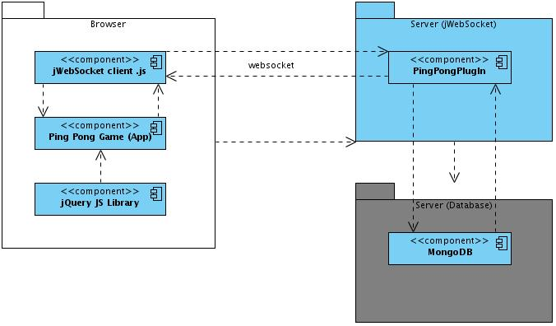
- The PingPong game uses the jQuery library for handling the UI.
- The PingPong game sends and receives data using the jWebSocket javascript client.
- The jWebSocket client uses the WebSocket protocol to communicate with the server application.
- The PingPong game is linked to the jWebSocket framework as a plugin.
- The server side PingPong game uses the MongoDB database to persist the game's data.

Modules
Project name | Ping Pong Game
Source code location | Server | Client
SVN branch | jWebSocket-1.0
To jQuery and the jWebSocket framework has been used to develop the PingPong game.
The server side:
A TokenPlugIn sends and receives the data generated by the users during the game. The server side module is structured as follows:
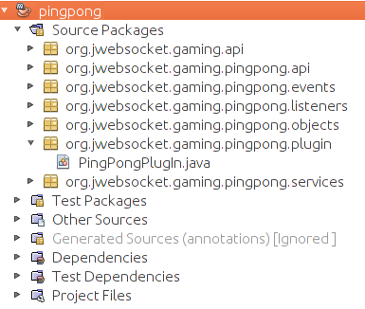
The client side:
The PingPong game has only a Web client, and it sources are located in the folder games/jwsPingPong.
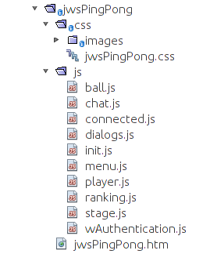
Used client libraries:
- jWebSocket.js: The jWebSocket framework JavaScript client library. Licence LGPL.
- jquery.js: The jQuery framework library for handling DOM nodes. Licence MIT and General Public Licence GNU v2.
- jquery-ui.js: The jQuery framework library for handling user interfaces. Licence MIT and General Public Licence GNU v2.
HTML documents and CSS files used to build the Web client:
Archivo | Descripción
jwsPingPong.htm | The file contains all the HTML code of the application.
jwsPingPong.css | The file contains the CSS rules for the HTML components styles.

Source code structure
Server:
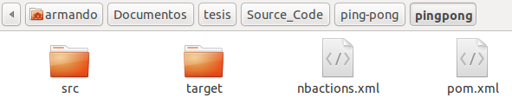

Items description:
src: A directory that contains all the source code files.
target: The directory contains the compiled sources, is not included in the “versioning of control”.
nbactions.xml: NetBeansIDE proyect configuration file.
pom.xml: Configuration file used by the Maven tool to compile the project.
Client:
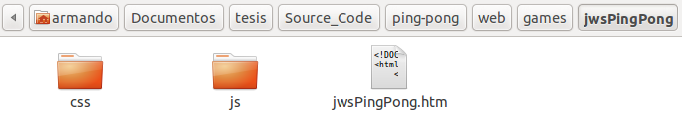
Items description:
css: The directory contains the CSS files of the Web client.
js: The directory contains the JavaScript files of the Web client.
jwsPingPong.htm: The file contains the HTML code of the Web client

Maven configuration
The module jWebSocketPingPong is configurable throught the pom.xml file, wish is a XML representation of the Maven project. The file contains various Maven components to be configured, i.e maven-jar-plugin, that allows to compile the application sources in a jWebSocketServer.jar file, configuration example:
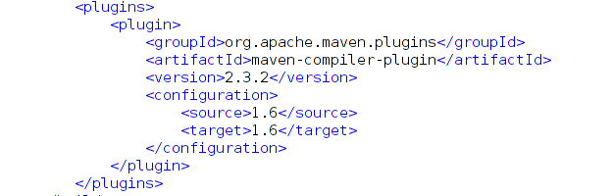
Once the project sources are compiled the jar file is copied to the directory rte/jWebSocket-1.0/libs/.
Maven dependencies of the PingPong game:
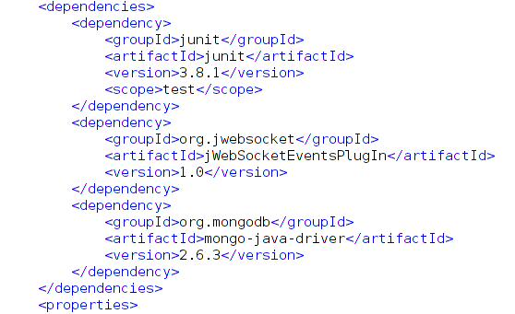

Packages Structure
The PingPong game java source codes are located in the namespace: org.jwebsocket.gaming.pingpong.plugin:
File | Description:
PingPongPlugIn.java | Receives/sends messages(tokens) from/to the game connected clients.

Coding standars:
See document “Coding Standard Template.doc”:
http://repo.hab.uci.cu/svn/tesis/Segundo_Corte_de_Tesis/JWS/Rolando%20Santamaria%20Maso/1%20corte/10-Plantilla Estandar de codigo.doc

Detailed description of the application code:
Server: The TokenPlugIn (PingPongPlugIn) methods:
processToken: Received incoming messages of the game connected clients
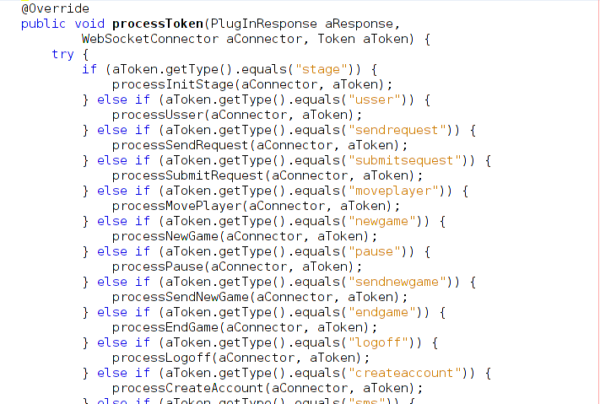

processCreateAccount: Register new users in the game

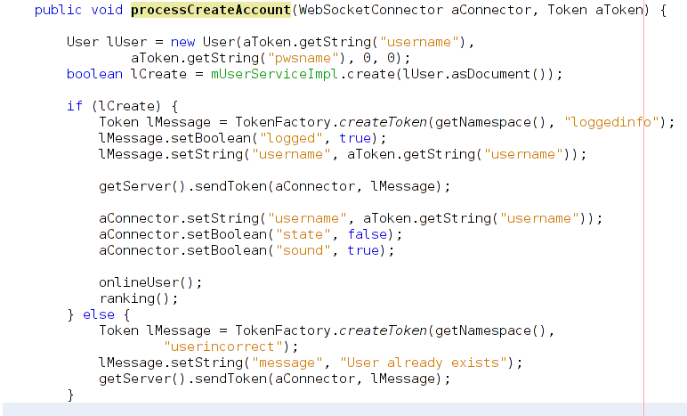

processEndGame: Allows to delete a match
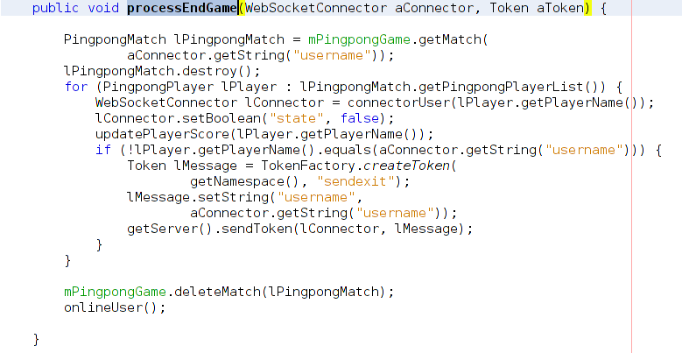
processInitStage: Initialize the game scenario
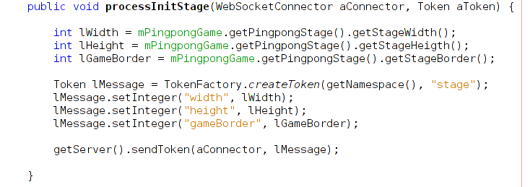

processLogoff: Close the user session
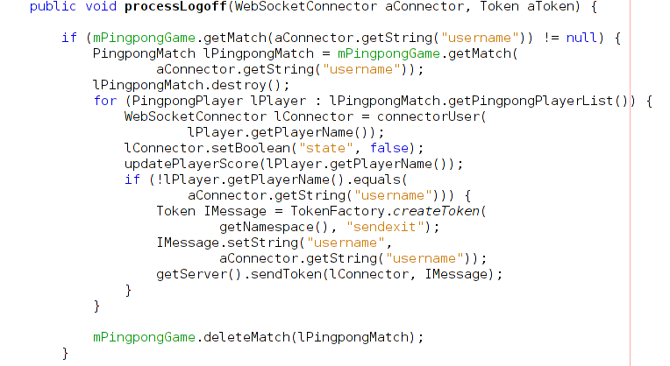
processMovePlayer: Move the players

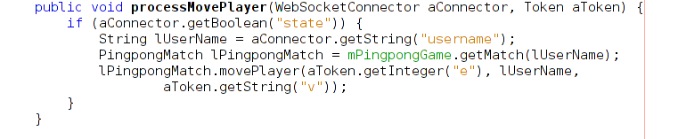
processNewGame: Create a new match
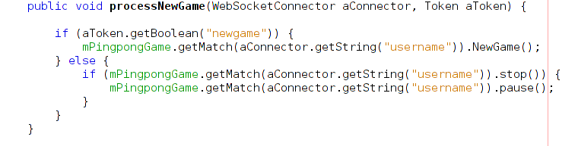

processPause: Pause/Continue a match
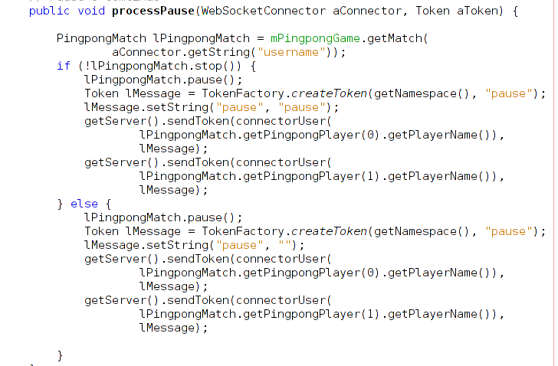
processSendRequest: Process the request to create a new match
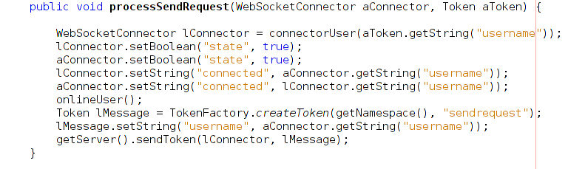

processSms: Send the chat messages beetwen players
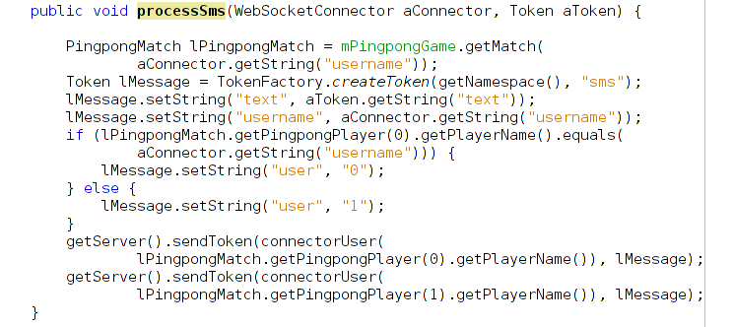
processSound: Enable/Disable the game sound
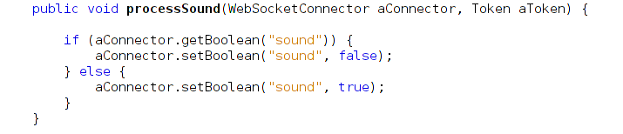
processUsser: Authenticate a user in the game
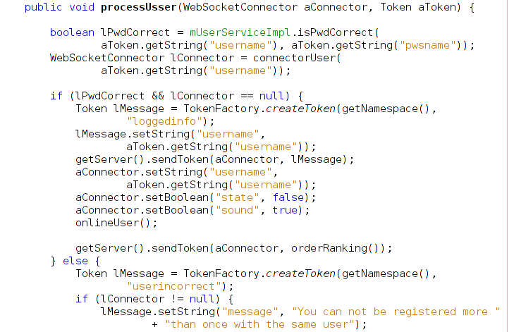
ranking: Generates the players ranking
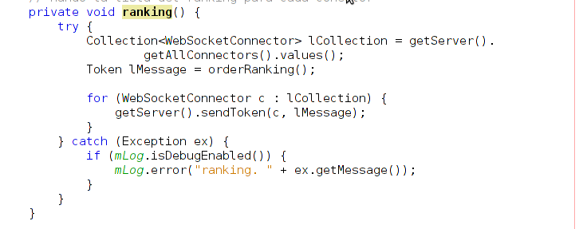
scoreUpdate: Update the score of the players

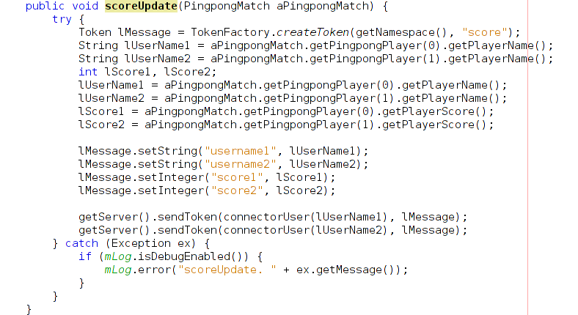
connectorStopped: Callback called when a client disconnect from the game
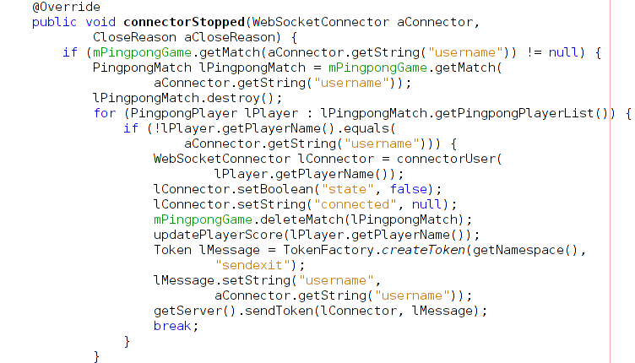
moveBall: Move the ball
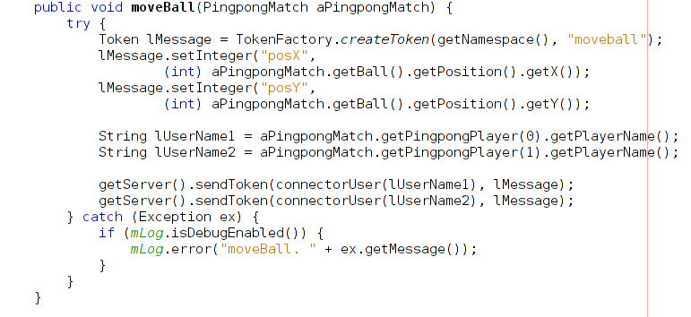

Client methods:
InitMenu: Initialize the menu buttons

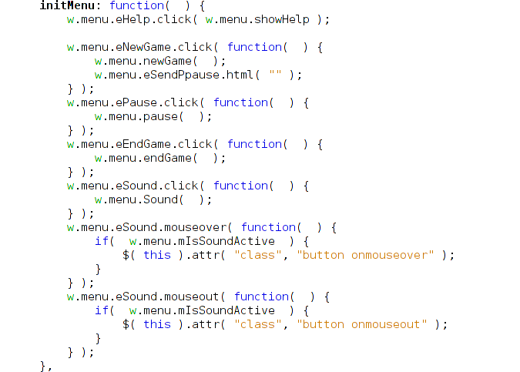
initRanking: Shows the players ranking
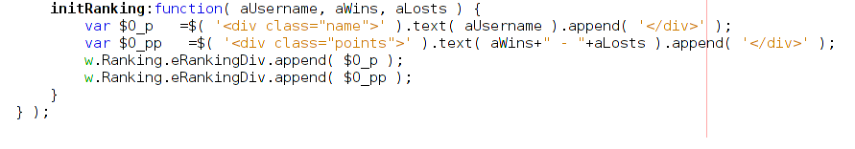
onMenssage: Capture all the messages that comes from the server
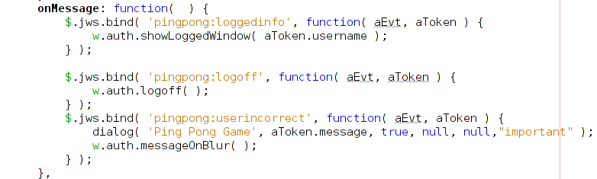

registerEvents: Register and process the client events
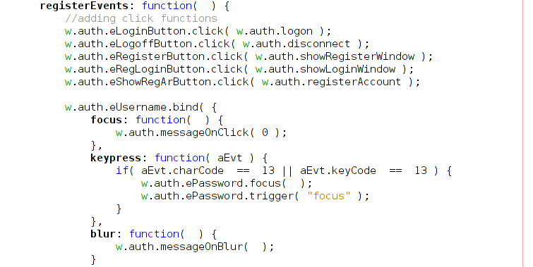
Used network protocol
The PingPong game is developed using the jWebSocket framework so the game uses the WebSocket protocol for the communication, this protocol offer a bidirecctional communication channel over a single TCP socket.
Programming model
The PingPong game is build in the event-driven programming paradigm, in wish the flow of the program is controlled by events. User events and game events.
Database
The PingPong game uses the MongoDB database server, wish is a no-sql database engine. MongoDB is famious because of the high speed and scalability.

MongoDB is used to store the user accounts and it rankings.
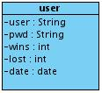

Collection: | user
Description: | The collection stores the user accounts and it raking score.
Campos | Tipo de Dato | Descripción
user | String | The unique username of a player.
pwd | String | The player password to access it account.
wins | int | Won games number.
lost | int | Lost games number.
date | date | Last access date of the player to the game.

